



JAVA PROGRAMMING
(340)

STATE 2024

PRODUCTION:
Java ___________ (520 points)

Test Time: 90 minutes

Java

In this test you will be creating another prototype seating chart software for your local school. The program will allow the user to be able to have control options through key board entries. There are three major actions of the program: (1) Randomly create student list; (2) Manually create students; and (3) Exit the program.

Input/Output Option [1]
All user input and output will take place in the console.

STEP 1: The program begins by asking the user what they would like today.
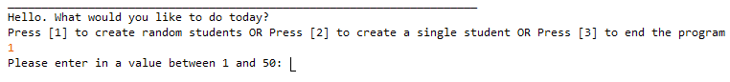
STEP 2 Option [1]: After entering 1, the program will ask the user to enter in a value between 1 and 50 (this number is how many students the program will create).
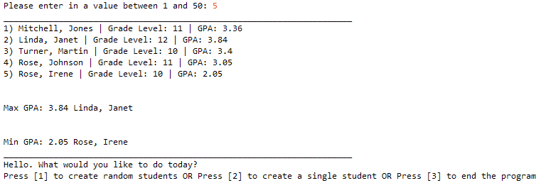
STEP 3 Option [1]: After entering the amount of student records to create, the program will list out the results. In addition, the program also finds the records with the Max GPA and Min GPA. After the list is created, the program returns to STEP 1.

Input/Output Option [2]
STEP 1: This the same as before. The user will be entering option [2].
STEPS 2-5 Option [2]: The user will enter in all the student information in this sequence.
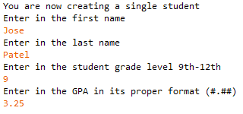
- STEP 2: First Name
- STEP 3: Last Name
- STEP 4: Grade Level
- STEP 5: GPA

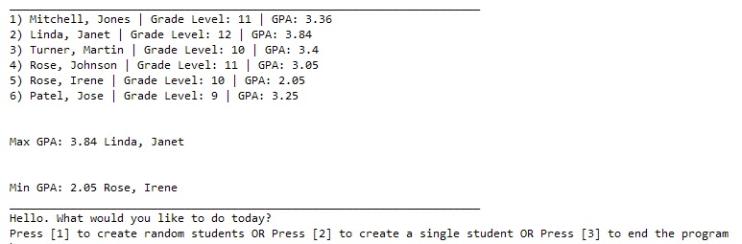
STEP 6: This is the output for the list. Notice that the record created is added to the end of the list that was previously created (the new student created is the 6th student). The program will still need to find the highest and lowest GPA. After listing, the program returns to STEP 1.
Input/Output Option [3]
STEP 1: This the same as before. The user will be entering option [3]. This will exit the software.

Error Messages:

Input/Output STEP 1 Invalid Data Error
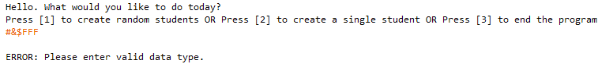
STEP 1: the user attempts to enter invalid data. Error message is given. The program needs to return to STEP 1.
Input/Output STEP 1 Range Violation
STEP 1: the user attempts to enter value outside of the range. “Your entry is out of range.” message is given. The program needs to return to STEP 1.
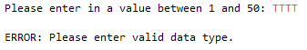
Input/Output STEP 2 Option [1] Invalid Data Error
STEP 2: the user attempts to enter invalid data. Error message is given. The program needs to return to STEP 2.

Input/Output STEP 2 Option [1] Range Violation
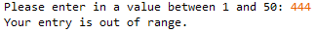
STEP 2: the user attempts to enter value outside of the range. “Your entry is out of range.” message is given. The program needs to return to STEP 2.

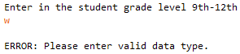
Input/Output STEP 4 Option [2] Invalid Data Error
STEP 4: the user attempts to enter invalid data. Error message is given. The program needs to return to STEP 4.

Input/Output STEP 4 Option [2] Range Violation
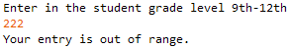
STEP 4: the user attempts to enter value outside of the range. “Your entry is out of range.” message is given. The program needs to return to STEP 4.

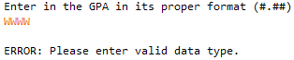
Input/Output STEP 5 Option [2] Invalid Data Error
STEP 5: the user attempts to enter invalid data. Error message is given. The program needs to return to STEP 5.

Input/Output STEP 5 Option [2] Range Violation
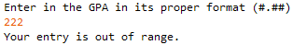
STEP 5: the user attempts to enter value outside of the range. “Your entry is out of range.” message is given. The program needs to return to STEP 5.

Solution and Project (There is NO partial credit) (NOTE: UC represents uppercase and LC represents lowercase)
The Java source file is present on the flash drive in a single folder with your contest ID |  | 20 points
Program Execution (If the program does not execute, then the remaining items in this section receive a score of zero)
Program starts STEP 1 |  | 10 points
STEP 1 Invalid Data Error is handled appropriately |  | 20 points
STEP 1 Range Violation is handled appropriately |  | 10 points
Option [1] is selected, program moves to appropriate STEP 2 |  | 10 points
STEP 2 Option [1] Invalid Data Error is handled appropriately |  | 20 points
STEP 2 Option [1] Range Violation is handled appropriately |  | 10 points
STEP 3 Option [1] Random students matches output & correct Max/Min GPA displayed |  | 30 points
After STEP 3 Option [1] Program returns immediately to active STEP 1 |  | 20 points
Option [2] is selected, program moves to appropriate STEP 2 |  | 10 points
STEP 4 Option [2] (Grade Level) Invalid Data Error is handled appropriately |  | 20 points
STEP 4 Option [2] (Grade Level) Range Violation is handled appropriately |  | 10 points
STEP 5 Option [2] (GPA) Invalid Data Error is handled appropriately |  | 20 points
STEP 5 Option [2] (GPA) Range Violation is handled appropriately |  | 10 points
STEP 6 Option [2] Student created in STEPS 2-5 appears in auto generated student original formatted list with proper formatting (first letter of names UC; Grade level is whole number; GPA #.##) |  | 30 points
After STEP 6 Option [2] Program returns immediately to active STEP 1 |  | 20 points
STEP 1 Option [3] program exits with goodbye message. |  | 10 points
 |  | 20 points
Subtotal |  | /280 Points

Source Code Review (There is NO partial credit) NOTE: you must place the comment flag in front of the comment in your code in order to get credit. The comment flag will precede the explanation. For example, if the flag is SC1, your comment must read as “#SC1…” in front of the part of the code being reviewed. Code must work to get credit. There is no partial credit.

A comment containing the contestant number is present at the top of the SeatingChartBuilderState.java file |  | 10 points
SC1: Students.java class: All constructors, methods, and variables are appropriately created; no partial credit |  | 40 points
SC2: SeatingChartBuilderState class: create Scanner and ArrayList objects (place SC2 by bother instances); no partial credit |  | 10 points
SC3: SeatingChartBuilderState class printHighestGPA( ): code that compares GPA’s for all students |  | 20 points
SC4: SeatingChartBuilderState class printLowestGPA( ): code that compares GPA’s for all students |  | 20 points
SC5: SeatingChartBuilderState class inputManager( ): code with try/catch exception for invalid data error and range violation of STEP 1 (place SC5 by both instances) |  | 20 points
SC6: SeatingChartBuilderState class inputManager( ): code with try/catch exception for invalid data error and range violation of STEP 2 Option[1] (place SC6 by both instances) |  | 20 points
SC7: SeatingChartBuilderState class inputManager( ): code with try/catch exception for invalid data error and range violation of STEP 4 Option[2] (place SC7 by both instances) |  | 20 points
SC8: SeatingChartBuilderState class inputManager( ): code with try/catch exception for invalid data error and range violation of STEP 5 Option[2] (place SC8 by both instances) |  | 20 points
SC9: SeatingChartBuilderState class inputManager( ): code that formats GPA with proper decimal format object (place SC9 by all uses of this object) |  | 10 points
SC10: SeatingChartBuilderState class inputManager( ): code that formats first and last name to required convention (first letter is UC, all other letters are LC) |  | 20 points
SC11: SeatingChartBuilderState class inputManager( ): code that exits the program STEP 1 Option [3] |  | 10 points
Subtotal |  | /240 Points
Total Points |  | /520 Points

